Raspberry Pi
Installation Instructions
Install Raspbian following instructions on http://raspbian.org/. Extend the file system to use the entire SD card and set the locale and time zone, e.g. en_US.UTF-8 UTF-8, using raspi-config as described at https://www.raspberrypi.org/documentation/configuration/raspi-config.md.

CouchDB
Ssh pi@<pi IP address>, e.g. ssh pi@192.168.10.142
password raspberry
pi@raspberrypi ~ $ aptitude show couchdb
Package: couchdb
State: not installed
Version: 1.2.0-5

too old! so don't do this:
# sudo apt-get install couchdb

Instead follow the instructions at https://cwiki.apache.org/confluence/display/COUCHDB/Debian for Debian versions >= 7.0, and CouchDB version 1.6.1, except for these changes:
(see also http://jeeonthepi.blogspot.ch/2014/08/installing-couchdb-1.html)

sudo apt-get install libmozjs185-1.0
instead of sudo apt-get install libmozjs185

skip the install of build-essentials, it's already the most recent

change the ownership of /usr/local/etc/couchdb/local.ini to couchdb

sudo apt-get install -y lsb-release
echo "deb http://binaries.erlang-solutions.com/debian `lsb_release -cs` contrib" | sudo tee /etc/apt/sources.list.d/erlang-solutions.list
wget -O - http://binaries.erlang-solutions.com/debian/erlang_solutions.asc | sudo apt-key add -
sudo apt-get update -y

sudo apt-get install -y libmozjs185-1.0
sudo apt-get install -y libmozjs185-dev
sudo apt-get install -y erlang-nox erlang-dev
sudo apt-get install -y libnspr4 libnspr4-0d libnspr4-dev libcurl4-openssl-dev curl libicu-dev

sudo useradd -d /var/lib/couchdb couchdb
sudo mkdir -p /usr/local/{lib,etc}/couchdb /usr/local/var/{lib,log,run}/couchdb /var/lib/couchdb
sudo chown -R couchdb:couchdb /usr/local/{lib,etc}/couchdb /usr/local/var/{lib,log,run}/couchdb
sudo chmod -R g+rw /usr/local/{lib,etc}/couchdb /usr/local/var/{lib,log,run}/couchdb

wget http://mirror.switch.ch/mirror/apache/dist/couchdb/source/1.6.1/apache-couchdb-1.6.1.tar.gz
tar xzf apache-couchdb-1.6.1.tar.gz
apache-couchdb-1.6.1.tar.gz
cd apache-couchdb-1.6.1/

./configure --prefix=/usr/local --with-js-lib=/usr/lib --with-js-include=/usr/include/mozjs --enable-init
make && sudo make install

sudo ln -s /usr/local/etc/init.d/couchdb /etc/init.d/couchdb
sudo /etc/init.d/couchdb start
sudo update-rc.d couchdb defaults
sudo chown couchdb:couchdb /usr/local/etc/couchdb/local.ini
curl http://127.0.0.1:5984/
cd ..

Futon
couchdb -c
/usr/local/etc/couchdb/default.ini
/usr/local/etc/couchdb/local.ini
sudo vi /usr/local/etc/couchdb/local.ini
[httpd]
bind_address = 0.0.0.0
sudo service couchdb restart
Browse to http://<pi IP address>:5984/_utils/, e.g. http://192.168.10.142:5984/_utils/
Change from Admin Party by adding an admin user by clicking the “Fix this” link in the lower right hand corner of Futon's main page. Provide user name, recommend: admin, and a password.

Replicate things
Choose “replicator” from the Tools menu on the right hand side.
In the form, click the Remote database radio button under Replicate changes from:, and enter the remote host things database URL, e.g. http://thingtracker.no-ip.org/root/things or http://192.168.10.103:5984/things. Under to:, enter “things” as the local database name.

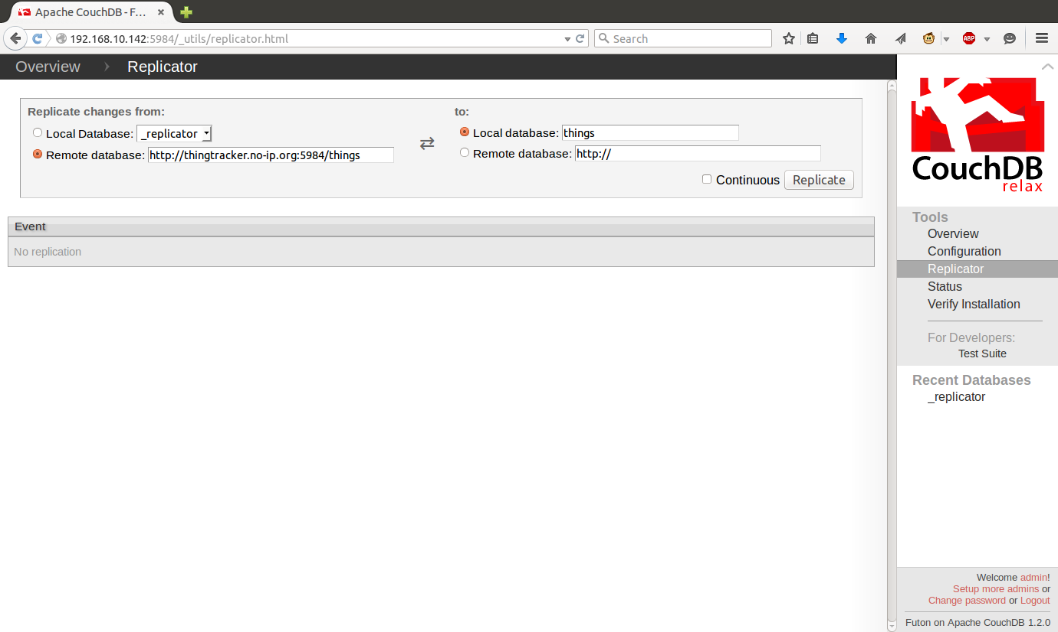
Push the Replicate button. Click OK in the This will create a database named things. Ok? confirmation dialog.
The Event log should display a JSON about the replication, e.g.
{"session_id":"c60d3644ce9e24ec40124b5ab3eb2dda","start_time":"Sun, 26 Apr 2015 09:46:09 GMT","end_time":"Sun, 26 Apr 2015 09:46:14 GMT","start_last_seq":0,"end_last_seq":57,"recorded_seq":57,"missing_checked":1,"missing_found":1,"docs_read":1,"docs_written":1,"doc_write_failures":0}

Configuration
Navigate to the things system http://<pi IP address>:5984/things/_design/things/_rewrite/, e.g. http://192.168.10.142:5984/things/_design/things/_rewrite/
and click all the buttons (description TBD).

Deluge
sudo apt-get install deluge
sudo apt-get install deluged
sudo apt-get install deluge-web
Start the daemon,
deluge-web
Navigate to the web page: http://<pi IP address>:8112/
Enter the password: deluge
For autostart (see http://www.onepitwopi.com/raspberry-pi/installing-deluge-1-3-6-on-a-raspberry-pi/) do this:

vi ~/.config/deluge/auth
add:
pi:raspberry:10

sudo vi /etc/default/deluge-daemon

# Configuration for /etc/init.d/deluge-daemon
# The init.d script will only run if this variable non-empty.
DELUGED_USER="pi"
# Should we run at startup?
RUN_AT_STARTUP="YES"

sudo vi /etc/init.d/deluge-daemon

#!/bin/sh
### BEGIN INIT INFO
# Provides: deluge-daemon
# Required-Start: $local_fs $remote_fs
# Required-Stop: $local_fs $remote_fs
# Should-Start: $network
# Should-Stop: $network
# Default-Start: 2 3 4 5
# Default-Stop: 0 1 6
# Short-Description: Daemonized version of deluge and webui.
# Description: Starts the deluge daemon with the user specified in
# /etc/default/deluge-daemon.
### END INIT INFO

# Author: Adolfo R. Brandes

PATH=/usr/local/sbin:/usr/local/bin:/sbin:/bin:/usr/sbin:/usr/bin
DESC="Deluge Daemon"
NAME1="deluged"
NAME2="deluge"
DAEMON1=/usr/bin/deluged
DAEMON1_ARGS="-d" # Consult `man deluged` for more options
DAEMON2=/usr/bin/deluge-web
DAEMON2_ARGS="" # Consult `man deluge-web` for more options
PIDFILE1=/var/run/$NAME1.pid
PIDFILE2=/var/run/$NAME2.pid
UMASK=022 # Change this to 0 if running deluged as its own user
PKGNAME=deluge-daemon
SCRIPTNAME=/etc/init.d/$PKGNAME

# Exit if the package is not installed
[ -x "$DAEMON1" -a -x "$DAEMON2" ] || exit 0

# Read configuration variable file if it is present
[ -r /etc/default/$PKGNAME ] && . /etc/default/$PKGNAME

# Load the VERBOSE setting and other rcS variables
[ -f /etc/default/rcS ] && . /etc/default/rcS

# Define LSB log_* functions.
# Depend on lsb-base (>= 3.0-6) to ensure that this file is present.
. /lib/lsb/init-functions

if [ -z "$RUN_AT_STARTUP" -o "$RUN_AT_STARTUP" != "YES" ]
then
log_warning_msg "Not starting $PKGNAME, edit /etc/default/$PKGNAME to start it."
exit 0
fi

if [ -z "$DELUGED_USER" ]
then
log_warning_msg "Not starting $PKGNAME, DELUGED_USER not set in /etc/default/$PKGNAME."
exit 0
fi

#
# Function that starts the daemon/service
#
do_start()
{
# Return
# 0 if daemon has been started
# 1 if daemon was already running
# 2 if daemon could not be started
start-stop-daemon --start --background --quiet --pidfile $PIDFILE1 --exec $DAEMON1 \
--chuid $DELUGED_USER --user $DELUGED_USER --umask $UMASK --test > /dev/null
RETVAL1="$?"
start-stop-daemon --start --background --quiet --pidfile $PIDFILE2 --exec $DAEMON2 \
--chuid $DELUGED_USER --user $DELUGED_USER --umask $UMASK --test > /dev/null
RETVAL2="$?"
[ "$RETVAL1" = "0" -a "$RETVAL2" = "0" ] || return 1

start-stop-daemon --start --background --quiet --pidfile $PIDFILE1 --make-pidfile --exec $DAEMON1 \
--chuid $DELUGED_USER --user $DELUGED_USER --umask $UMASK -- $DAEMON1_ARGS
RETVAL1="$?"
sleep 2
start-stop-daemon --start --background --quiet --pidfile $PIDFILE2 --make-pidfile --exec $DAEMON2 \
--chuid $DELUGED_USER --user $DELUGED_USER --umask $UMASK -- $DAEMON2_ARGS
RETVAL2="$?"
[ "$RETVAL1" = "0" -a "$RETVAL2" = "0" ] || return 2
}

#
# Function that stops the daemon/service
#
do_stop()
{
# Return
# 0 if daemon has been stopped
# 1 if daemon was already stopped
# 2 if daemon could not be stopped
# other if a failure occurred

start-stop-daemon --stop --quiet --retry=TERM/30/KILL/5 --user $DELUGED_USER --pidfile $PIDFILE2
RETVAL2="$?"
start-stop-daemon --stop --quiet --retry=TERM/30/KILL/5 --user $DELUGED_USER --pidfile $PIDFILE1
RETVAL1="$?"
[ "$RETVAL1" = "2" -o "$RETVAL2" = "2" ] && return 2

rm -f $PIDFILE1 $PIDFILE2

[ "$RETVAL1" = "0" -a "$RETVAL2" = "0" ] && return 0 || return 1
}

case "$1" in
start)
[ "$VERBOSE" != no ] && log_daemon_msg "Starting $DESC" "$NAME1"
do_start
case "$?" in
0|1) [ "$VERBOSE" != no ] && log_end_msg 0 ;;
2) [ "$VERBOSE" != no ] && log_end_msg 1 ;;
esac
;;
stop)
[ "$VERBOSE" != no ] && log_daemon_msg "Stopping $DESC" "$NAME1"
do_stop
case "$?" in
0|1) [ "$VERBOSE" != no ] && log_end_msg 0 ;;
2) [ "$VERBOSE" != no ] && log_end_msg 1 ;;
esac
;;
restart|force-reload)
log_daemon_msg "Restarting $DESC" "$NAME1"
do_stop
case "$?" in
0|1)
do_start
case "$?" in
0) log_end_msg 0 ;;
1) log_end_msg 1 ;; # Old process is still running
*) log_end_msg 1 ;; # Failed to start
esac
;;
*)
# Failed to stop
log_end_msg 1
;;
esac
;;
*)
echo "Usage: $SCRIPTNAME {start|stop|restart|force-reload}" >&2
exit 3
;;
esac

:

sudo chmod +x /etc/init.d/deluge-daemon

To get deluge-web to connect to the daemon automatically, stop the daemon, then fill in the default_daemon value and make the file read-only:

sudo vi ~/.config/deluge/web.conf
{
"file": 1,
"format": 1
}{
"port": 8112,
"enabled_plugins": [],
"pwd_sha1": "2ce1a410bcdcc53064129b6d950f2e9fee4edc1e",
"theme": "gray",
"show_sidebar": true,
"sidebar_show_zero": false,
"pkey": "ssl/daemon.pkey",
"https": false,
"sessions": {},
"base": "/",
"pwd_salt": "c26ab3bbd8b137f99cd83c2c1c0963bcc1a35cad",
"show_session_speed": false,
"first_login": false,
"cert": "ssl/daemon.cert",
"session_timeout": 3600,
"default_daemon": "127.0.0.1:58846",
"sidebar_multiple_filters": true
}
chmod -w ~/.config/deluge/web.conf
sudo reboot

vhost
Set up your router so that your DNS name hits the raspberry pi:
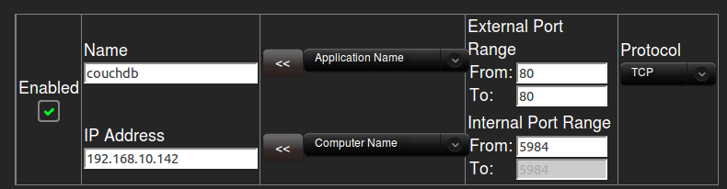

Then add a vhost entry in couchdb.ini

pi@raspberrypi ~ $ couchdb -c
/usr/local/etc/couchdb/default.ini
/usr/local/etc/couchdb/local.ini
pi@raspberrypi ~ $ sudo vi /usr/local/etc/couchdb/local.ini

[vhosts]
thingtracker.no-ip.org = /things/_design/things/_rewrite/

[httpd]
secure_rewrites=false

pi@raspberrypi ~ $ sudo service couchdb restart

There is already an entry in the rewrites section like so:

{ "from": "root", "to": "../../.." },
{ "from": "root/*", "to": "../../../*" },

and a prefix is added to all the CouchDB jQuery plugin calls by setting the prefix, like so:

$.couch.urlPrefix = “/root”;

in main.js.

